MOSAIQ Field Size Limit

According to the Machine Characterization of both E1 and E2 in MOSAIQ, the maximum field size for a treatment field should be 40×40:

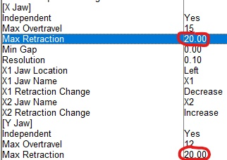

Yet the maximum field size that can be set is 40×32 (or 32×40).

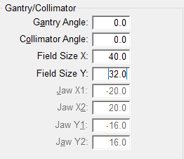

MOSAIQ support says the following:

For non-mlc fields each jaw pair can retract to a full 40 cm position but due to the outer leaves not being able to retract completely, both jaws cannot be defined with 40 cm at the same time. The largest field size a non-MLC field can have is 40 x 32.5. However, a 40 x 40 cm field can be achieved using Simple MLC because this option uses the limits of the jaw and not the MLC from the MAC. Because the outside leaves wont retract all the way the virtual jaw line stops at the least most retracted position.

So, the **Max Retraction** setting in Machine Characterization applies to the virtual jaws, not the physical jaws. I have no idea how this difference plays into treatment field definition, though! Unfortunately, the MOSAIQ user documentation does not provide detailed explanations of the Machine Characterization fields.